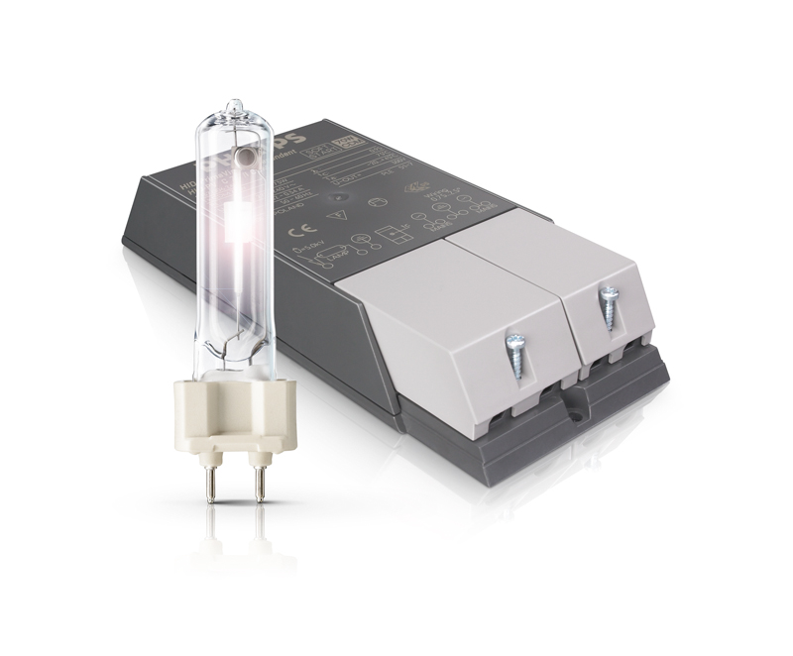

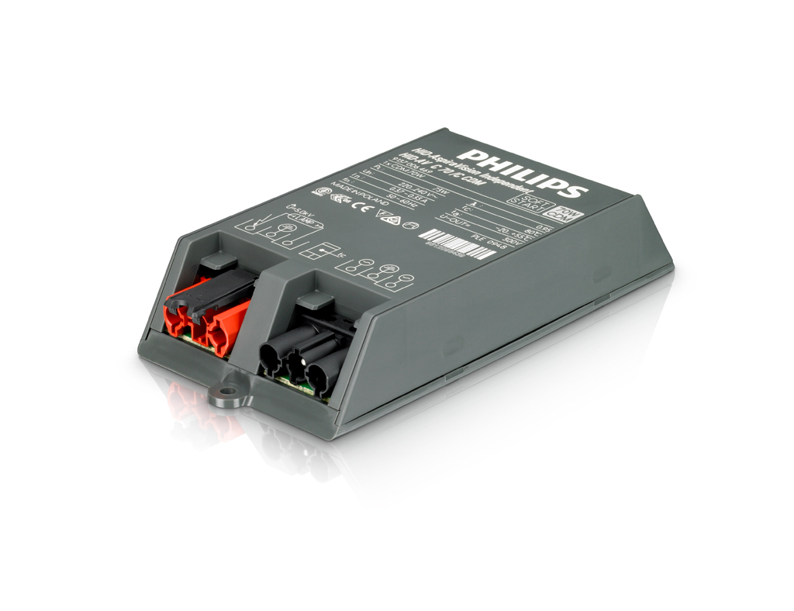

Philips Lighting Electronics
GDC Eindhoven
Author: Sjef Jansen
March 2012

9137-006-53166 sh-460 2012-03-29

Contents

1. Introduction 3
2. Version management 3
3. Ordering 3
4. Dimensions 3
5. Temperature behaviour 4
6. Wiring 6
7. Electro-Magnetic Compatibility 7
8. Factory handling 8
9. Installation / Mounting 9
10. Operating in abnormal conditions 11
11. Advised communication 11
12. Frequently Asked Questions 12
13. For more information 12

Introduction
The PrimaVision Compact family has been extended to include Connector version as well. The PrimaVision Connector 35W, 50W and 70W fulfil to CISPR 15 ed 7.2. The new drivers have the same footprint as their predecessors to allow easy design-in.

Version management
This is the design-in sheet for the PrimaVision Compact 35 /C, 50 /C and 70 /C
drivers.
Status of the product: Sampling

13-10-2010: 9137-006-531 sht-460 2010-10-13
Added PrimaVision Compact 50 /I
22-01-2010: 9137-006-531 sht-460 2010-04-21
Initial document
29-03-2012: 9137-006-531 sht-460 2010-04-21
Added PrimaVision Compact 35/C, 50/C and 70/C

Ordering
Technical name: HID-PV C 35 /I CDM HID-PV C 35 /C CDM
12NC: 9137 006 53166 9137 006 84466
EAN3: 8727900859737 tbd
EOC: 872790085973700 tbd

Technical name: HID-PV C 50 /I CDM HID-PV C 50 /C CDM
12NC: 9137 006 65166 9137 006 84566
EAN3: 8727900933666 tbd
EOC: 872790093365900 tbd

Technical name: HID-PV C 70 /I CDM HID-PV C 70 /C CDM
12NC: 9137 006 53266 9137 006 84666
EAN3: 8727900859881 tbd
EOC: 872790085988100 tbd

Product | Qty  box/pallet | Net. weight  (kg) | Box Dim.  LxWxH (mm) | Pallet Dim.  LxWxH (mm)
HID-PV C 35 /I CDM | 12/648 | 0.360 | 244x193x266 | 1200x800x948
HID-PV C 35 /C CDM | 12/648 | 0.290 | 244x193x266 | 1200x800x948
HID-PV C 50 /I CDM | 12/648 | 0.360 | 244x193x266 | 1200x800x948
HID-PV C 50 /C CDM | 12/648 | 0.290 | 244x193x266 | 1200x800x948
HID-PV C 70 /I CDM | 12/648 | 0.360 | 244x193x266 | 1200x800x948
HID-PV C 70 /C CDM | 12/648 | 0.290 | 244x193x266 | 1200x800x948

Dimensions

Independent version
The PrimaVision Compact 35W /I, /C, 50W /I, /C and 70W /I, /C share the same dimensions
The mounting holes are on the same position as it predecessor, to enable drop-in
replacement.

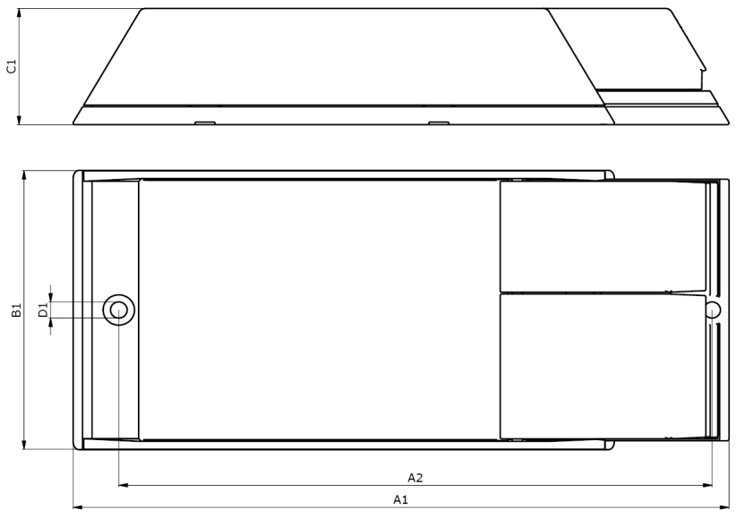

A1 (mm) | A2 (mm) | B1 (mm) | C1 (mm) | D1 (mm)
188 | 170 | 83 | 34.5 | 4.8

Connector version

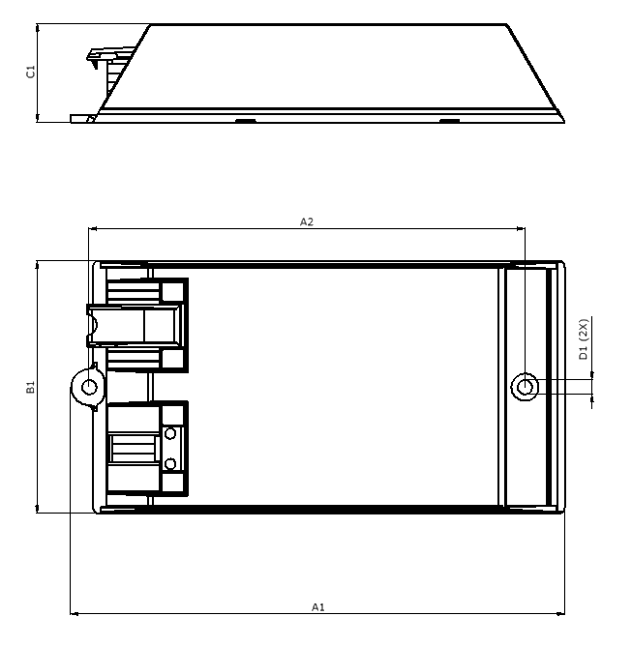

A1 (mm) | A2 (mm) | B1 (mm) | C1 (mm) | D1 (mm)
161.7 | 143 | 83 | 32.4 | 4.8

Temperature behaviour

T_{case}
The T_{case} point is used as a reference-point, to determine the maximum allowed temperature of the housing. To guarantee safety and lifetime of the driver, it is not allowed to exceed T_{case max}.
The position is shown on the picture.

Independent version

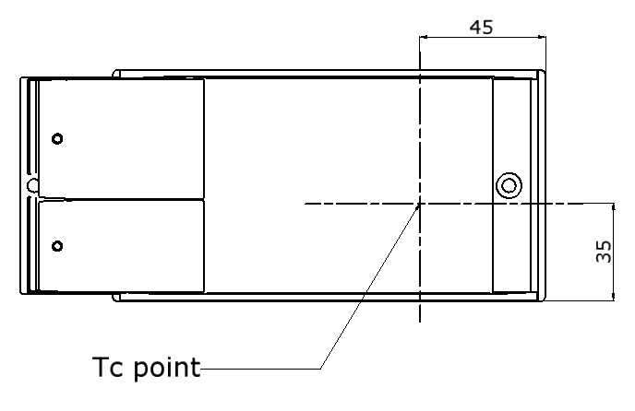
55
43

Connector version
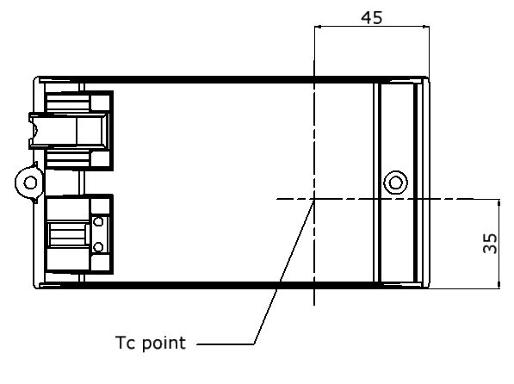

Lifetime 40k hours/90% survivals:
 | T_{case} –max | T_{ambient} –max
HID-PV 35 /I CDM | 75°C | 50°C
HID-PV 35 /C CDM | 75°C | 50°C
HID-PV 50 /I CDM | 75°C | 50°C
HID-PV 50 /C CDM | 75°C | 50°C
HID-PV 70 /I CDM | 75°C | 45°C
HID-PV 70 /C CDM | 75°C | 45°C

Driver losses
The PrimaVision Compact drivers have been developed to realize the highest power efficiency and operate with low losses for a long reliable lifetime.

Temperature Testing
Because the driver will regulate the lamp to a constant power, the input current will increase when the input voltage is lower. This ultimately will influence the power losses, so the worst-case temperature should therefore be measured at lowest mains voltage of 198V.

To guarantee, that the maximum value of T_{case}. is not exceeded, a thermo-couple should be mounted on the T_{c} point of the driver.

For more information about lifetime and temperature please consult the HID application guide.

Wiring
The wiring should be connected according the pictures below. This driver is equipped with a safety earth connection and must be connected to the earth connection of the mains-supply.
For EMI-reasons, it is important to make the “hot” lamp-wire (indicated by the .symbol) as short as possible.

Independent version
This driver has a loop-through possibility for the mains-wiring.

Connector type: Push-in contacts, WAGO type 804
Wire cross section: 0.75-2.5 mm² massive or stranded
Strip length: 10-11mm
Max cable capacitance lamp-wires: 150 pF
Maximum length lamp-wires: 2.0m

Connector version

Mains connector:
Connector type: Wieland GST18i3 Male without
lock.
Color: black

Lamp connector:
Connector type: Wieland ST18/3 Female with lock
Color: red
Max cable capacitance lamp-wires: 150 pF
Maximum length lamp-wires: 2.0m

Electro-Magnetic Compatibility
The driver is tested and approved according CISPR 15 ed. 7.2.
However the position of the wiring can negatively influence the EMC performance of this HID-system. Therefore it is advised to pay attention to the following:
- Place the mains wires in such a way, that they are not in parallel with the lamp wires.
- Make the spacing between lamp and mains wires as big as possible.
- Keep the mains wires close together.
- Keep the lamp wires close together and preferably as short as possible. Do not exceed the maximum allowed length of the lamp wires.

Factory handling

Traceability
For traceability reasons year and week of production, as well as production-location, can be found on the product-label.

The production-code consists of production year and week.

Example: If a product has been marked 0810 :
- Position 1 and 2 are the last digits from the year of production. The digits 08 indicates that the product has been made in 2008
- Position 3 and 4 indicate the week of production. The number 10 indicates that the product has been made in week 10.
- Furthermore, each product has a serial number, including barcode. (This is depending of the production-location)

Installation / Mounting

Lamps that can be driven by the driver
Driver | Lamp
HID-PV C 35W /I  HID-PV C 35W /C | All CDM 35W lamps, excluding: CDM-Tm PGJ5 35W lamps
HID-PV C 50W /I  HID-PV C 50W /C | All CDM 50W lamps
HID-PV C 70W /I  HID-PV C 70W /C | All CDM 70W lamps

The drivers are not compatible with the following lamps:
- Metal halide quartz lamps

Suitable application for this driver
This product is designed mainly for applications that are working in an Indoor environment (IP23 or superior casing).
Typical applications are:
- Spot and accent lighting
- Downlighting and general lighting
- Mini flood lighting
- Main segment is retail (shops)
- Secondary segments are office and health care

The PrimaVision Compact range is not intended for Outdoor use due to the following outdoor constraints:
- High humidity and condensation risks
- Vibrations e.g. when the luminaire is mounted on a public lighting pole
- Lightning surges on the mains. Outdoor electronics gear are 4kV protected but the HID-PV C 35W/50W/70W is protected up to 2kV.
Therefore, it is the responsibility of the luminaire manufacturer and the installer to take into account the above and implement adequate protection for the above. Here are some requirements for Outdoor applications:
- Place the gear in an IP54 or higher environment
- Avoid placing the gear or luminaire in high poles
- Place adequate Lightning protection in the lighting installation
- Planner should take it into account for Cost of Ownership calculations and maintenance plans.

If the above points are not taken into account in the design and the installation, Philips will have the option not to apply the standard guarantee.

Maximum number of gear per MCB
The maximum number of drivers, which can be connected to a B type 16A is 24x
35W, 24x 50W or 20x 70W. For other types apply conversion table below:

Conversion table for max. Quantities of driver on other types
of Miniature Circuit Breaker
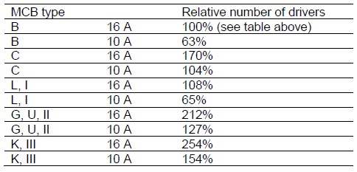

Remark: L, G and U are old type MCB.

DC-operation
This driver is not designed for DC operation.

Mounting
The strain reliefs can be closed by means of 2 (pre-assembled) slotted crosshead screws of the PZ1 type. The maximum allowed torque for mounting the screws is 1.0Nm.
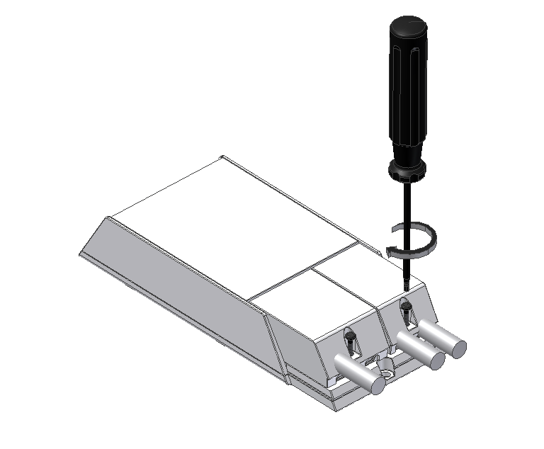
There are several methods to install the driver:
- The driver can be mounted on a solid surface by means of 2 M4 screws.
- The driver can be placed on the ceiling, without any means to fix it. (It is advised, not to place the driver upside down)
- A metal hook can be applied to one of the mounting holes of the driver, to hang it on the construction of the ceiling. (it is advised to have the wires/connectors facing down)

In all this situations, it is important not to cover the driver by any (isolating) material.

Operating in abnormal conditions
Active Thermal protection
If the driver is used at a too high temperature an internal thermal protection will
protect the driver against damage; the driver will switch off the lamp. Mains
voltage needs to be reset in order to reset thermal protection.The thermal protection becomes active at Tcase > 95°C.

Mains voltage
The gear is designed to operate within a operational/safety range of 180-264V. However the performance is guaranteed within the performance range of 198-254V. Within this range, the lamp power is regulated within ±3% of its nominal power. (Valid for a lamp voltage between 80 and 90V)

Over voltage
The driver has a limited protection against over voltage, it is advised to prevent
higher mains voltages than +10%. This will however negatively influence the
lifetime and reliability.

Lightning and power surges
Protection against surges because of lightning are built in the gear.
IEC61547, surge levels: 1.0kV Line to Line and 2.0kV Line to GND

End Of Life (EOL) lamp protection
The driver has a protection against an End Of Life Lamp. The driver will detect the failing lamp and switch to standby. After re-lamping, the mains has to be switched off and on, in order to reset the driver.

Mains dips
If mains dips occur that cause the lamp to extinguish, the driver will automatically
re-ignite the lamp for a maximum of three times after a cooling-down period of
approximately 10 minutes. After the last attempt the mains power needs to be
cycled to reset the internal ignition timer of the driver.

Advised communication
Philips Lighting Electronics advises to communicate the following information to your customers via your preferred media: Catalogues, brochures, Product datasheets, Mounting instructions, Internet and Intranet.

Technical
Due to lamp characteristics, this driver needs some time to re-ignite (10…15 minutes) after switch-off.
When the lamp has reached end of life, the driver will switch off the lamp in order to avoid lamp overheating. After lamp replacement, the mains voltage will have to be reset and the system will work normally. The driver does not need to be replaced. The PrimaVision driver range is equipped with an internal thermal-sensor, that will prevent loss of driver lifetime due to overheating in the luminaire/installation.
Marketing
The use of PrimaVision Compact in your luminaire will provide your customer the
following benefits:
• Optimum system performance
Development of CDM lamps and driver is in one hand. Every product is
tested extensively, requiring a million burning hours before a system can
be released. The result is an optimal light performance with Philips
MASTERColour CDM lamps.
• Flicker free operation
• 30 to 40% longer lamp lifetime
• 10% energy saving compared to a Electromagnetic system
• Safe and comfortable behaviour when lamp reaches End of Life
Furthermore, the PrimaVision Compact range has low losses, which guarantees
maximum energy savings and limit heat generation, translating into a longer driver lifetime.

Guarantee
The guarantee of 3 and 5 years for Philips Electronics is applicable for this product. For more information about guarantee, please visit our website:
www.philips.com/ehid

Frequently Asked Questions
Is the new HID-PV Compact Independent compatible with the existing
generation?
Yes. The outer dimensions of the PrimaVision Compact I are the same as the
predecessor; enabling drop-in replacement.
The EMC performance is complying with the new CISPR 15 ed 7.2 requirements.
Does the HID-PV Compact Independent also offer SOFT START?
No, this feature is only available in AspiraVision range.
Does the HID-PV Compact Independent offer the possibility for loopthrough
mains wiring?
No, this feature is only available in the AspiraVision-range.
The housing is plastic. Does this give problems with EMC or temperature?
No, the gear is specially developed for the housing. Therefore, no problems with
EMC and temperature occur.

For more information
Please contact your local sales representative.
Check OEM application guide for general information about electronic gear.
Visit our web-site www.philips.com/ehid

