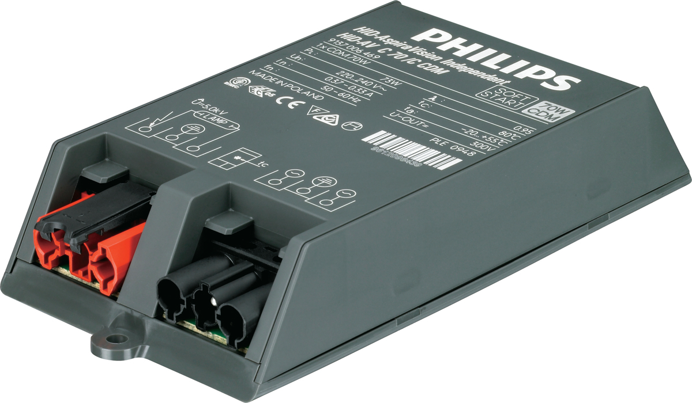PrimaVision Compact for
CDM

HID-PV C 35/C CDM 220-240V 50/60 Hz

High-quality, compact and lightweight HID electronic gear for optimal
and reliable performance of 35, 50 and 70 W CDM lamps

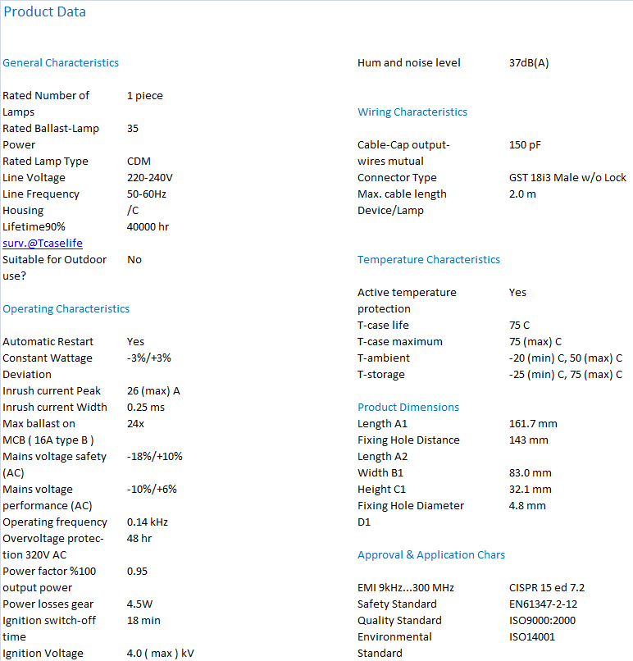

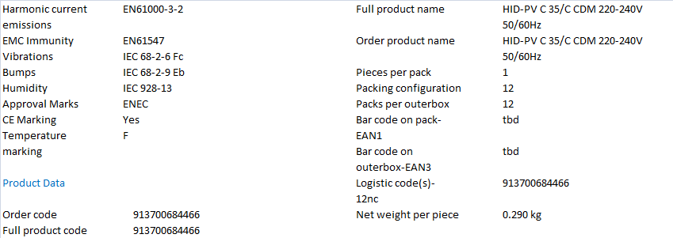

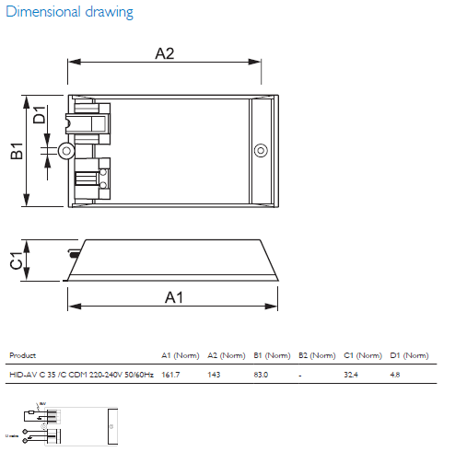
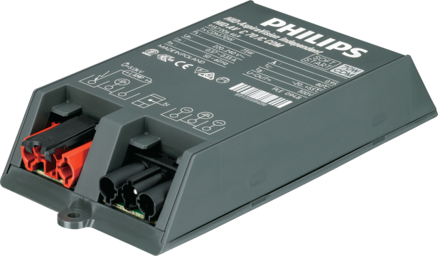
PrimaVision Compact for
CDM

HID-PV C 50/C CDM 220-240V 50/60 Hz

High-quality, compact and lightweight HID electronic gear for optimal
and reliable performance of 35, 50 and 70 W CDM lamp

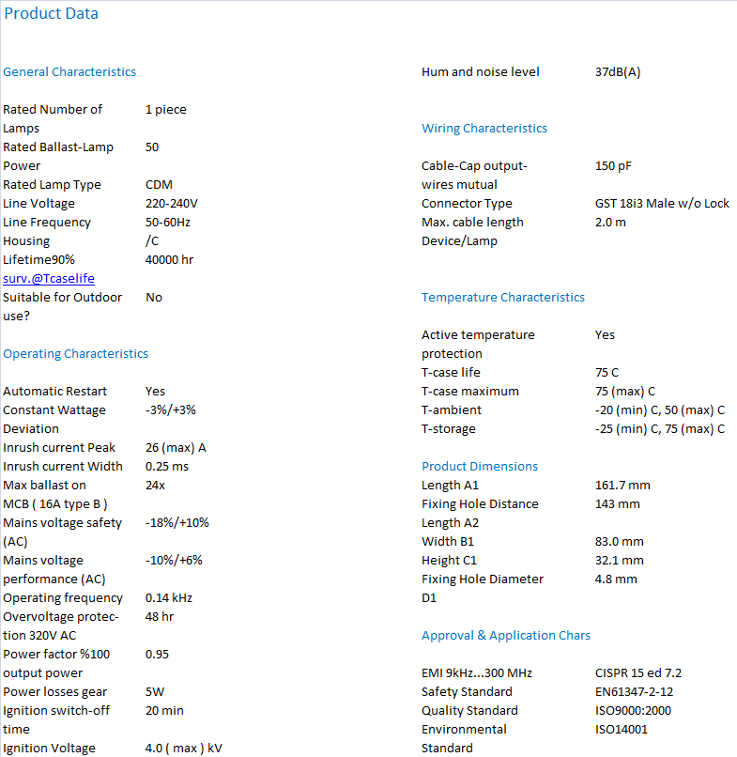
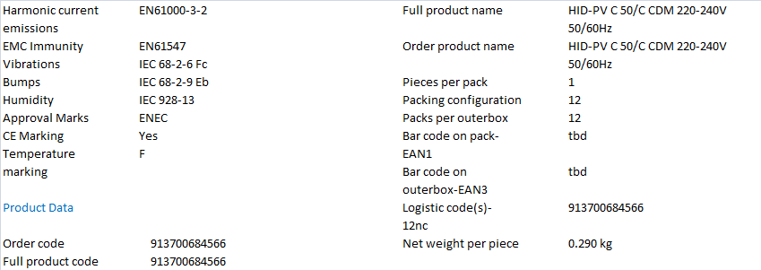

PrimaVision Compact for
CDM

HID-PV C 70/C CDM 220-240V 50/60 Hz

High-quality, compact and lightweight HID electronic gear for optimal
and reliable performance of 35, 50 and 70 W CDM lamp

